EXPT NO:5 | DASHBOARD DESIGNING
Roll No: 23BAD078 | DASHBOARD DESIGNING
DATE: 24.01.2026 | DASHBOARD DESIGNING

PRE-LAB QUESTIONS
- How do dashboards support strategic decision-making?

Answer: Dashboards support strategic decision-making by presenting key performance indicators in a visual and real-time format, helping managers identify trends, monitor goals, and make data-driven decisions quickly.

- What role do dashboards play in AI monitoring systems?

Answer: Dashboards monitor AI model performance and behavior by visualizing metrics like accuracy, error rates, and drift, enabling early detection of issues and ensuring reliable AI systems.

- Why is interactivity essential in modern dashboards?

Answer: Interactivity allows users to filter, drill down, and explore data, leading to better understanding, personalized analysis, and more informed decisions.

- What cognitive overload issues exist in dashboards?

Answer: Cognitive overload occurs when dashboards display too much information, cluttered visuals, or poor color and layout design, making data hard to interpret.

- How are KPIs derived from raw data?

Answer: KPIs are derived by cleaning, aggregating, and transforming raw data into meaningful metrics aligned with business objectives.

OBJECTIVE: To design an interactive analytical dashboard for monitoring key metrics.
SCENARIO: An AI-based smart campus system requires a dashboard to monitor attendance, academic performance, and resource utilization in real time.
IN-LAB TASKS (Using PowerBI)
• Design KPI cards for attendance and performance
• Implement filters by department and semester
• Link multiple views for drill-down analysis

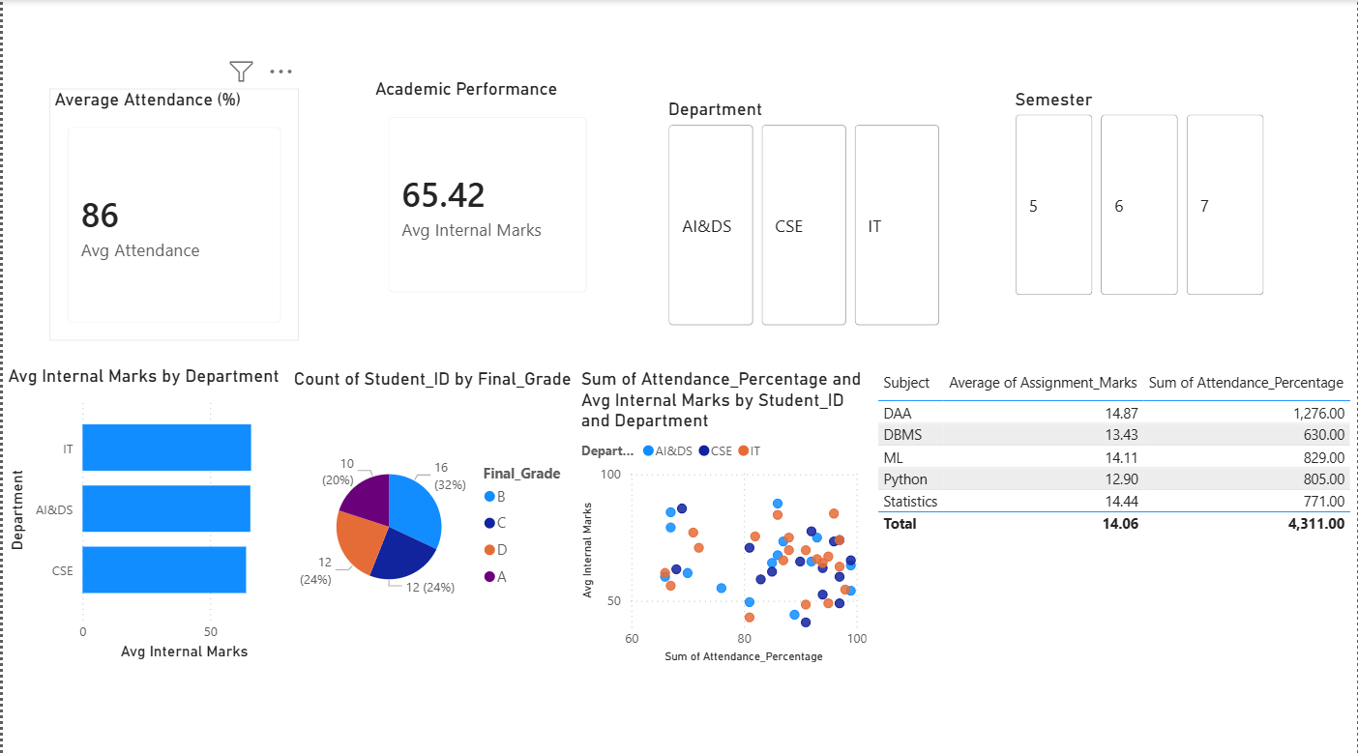

POST-LAB QUESTIONS
- How does interactivity improve analytical depth?

Answer: Interactivity allows users to filter, drill down, and explore data dynamically. It helps analyze performance by department, semester, or student, revealing patterns like the relationship between attendance and marks.

- Which KPIs are critical for academic monitoring?

Answer: Key KPIs include average attendance, average internal marks, subject-wise performance, grade distribution, and department-wise results. These metrics help track student engagement and academic outcomes.

- What design principles prevent information overload?

Answer: To prevent information overload, dashboards must follow effective design principles:
- Visual hierarchy: Highlight important KPIs using cards and larger fonts
- Minimalism: Avoid unnecessary visuals, excessive colors, or clutter
- Consistent color coding: Same colors represent the same departments or metrics
- Aggregation first, details on demand: Show summaries first and allow drill-down
- Proper layout and spacing: Improves readability and focus

- How can dashboards be integrated with AI alerts?

Answer: Dashboards can be enhanced by integrating AI-driven alert systems that proactively notify stakeholders. This integration can be done by:
- Using AI models to predict low attendance or poor academic performance
- Setting threshold-based alerts (e.g., attendance < 75%)
- Triggering real-time notifications via email, SMS, or in-app alerts
- Applying anomaly detection to spot sudden drops in performance

- How do dashboards enhance transparency in institutions?

Answer: Dashboards promote transparency by providing clear, real-time, and accessible information to all stakeholders.
They enhance transparency by:
- Presenting standardized metrics across departments
- Reducing data manipulation and subjective reporting
- Enabling faculty, administrators, and management to view the same source of truth
- Supporting evidence-based discussions and accountability

LEARNING OUTCOME: Students understand dashboard design for AI-driven environments.
ASSESSMENT
Description | Max Marks | Marks Awarded
Pre Lab Exercise | 5
In Lab Exercise | 10
Post Lab Exercise | 5
Viva | 10
Total | 30
Faculty Signature

